Hotel Reservation and Billing system

In this project, there will be two module Guest module for Reservation and Hotel module for billing and validation. In Guest module guest can reserve room, see the available rooms with specification like Wi-fi, air-conditioner etc. In the Hotel module hotel employees, can see the bill of a guest and issue a bill statement. A Guest can be a club member of that hotel in that case he will be charged less in booking room or using facility.

This is the ER diagram of our system.

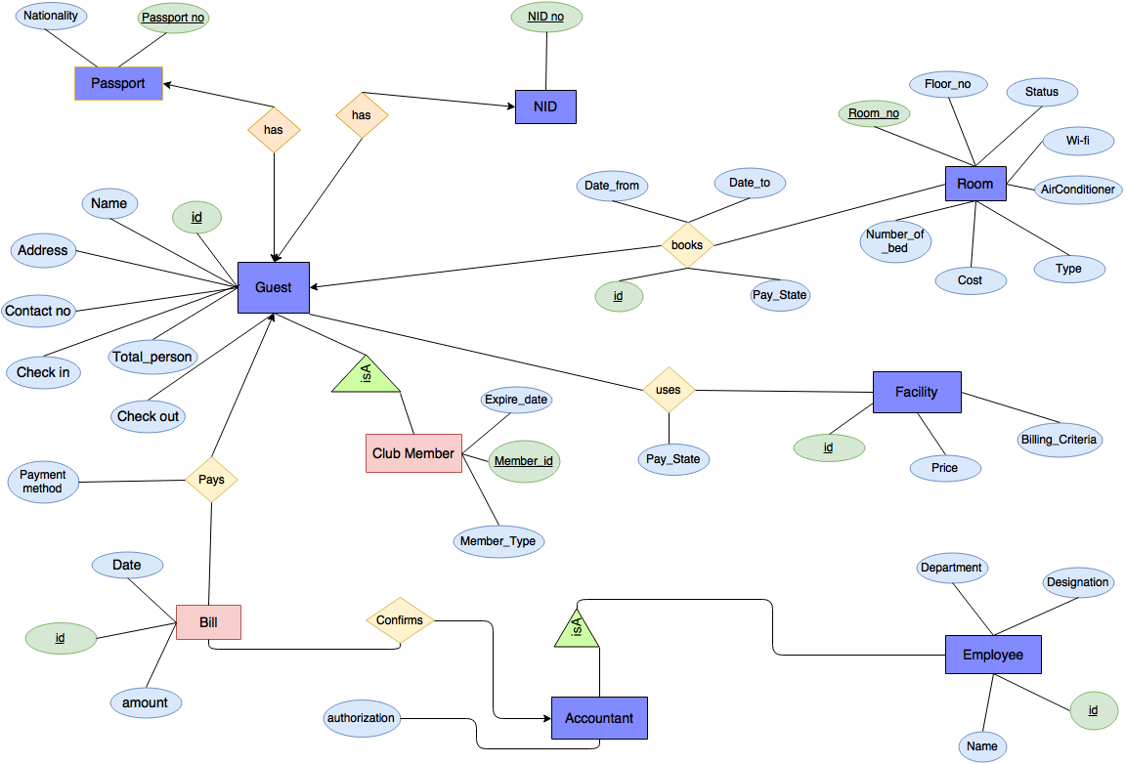

In the next page the probable name of tables and queries are described.

Club:

Is guest a club member: Query in club_member table with the given member id.

Is guest a valid member: Checking from member table is the membership expiration date is ok.

Category: Is Guest a premium member or a basic member.

Guest:

NID or Passport: Guest must provide NID or Passport no.

Total person: Guest cannot have more people then the number of bed in the room he booked.

Check in: Hotel employee will register the check in time of a guest if he is available in NID or passport table.

Check out: Hotel employee will register the checkout time of a guest if he has paid all the bills.

Bill:

Pay method: What is the method of payment?

Date: When the bill is issued.

Confirmation: Who confirmed the bill?

Amount: Bill amount will be calculated from facility and room table.

Room:

Availability: Is room available?

Price, category, cost:

Room no: Who has been boarded in this room.

Payment: Is the booking already been paid?

Employee:

Confirmation: Who has been issued this bill?

Validation: Has he authorization to issue bill?

Facility (Gymnasium, swimming pool, room services):

Uses: Which facility guest uses and how much times?

Cost: Cost for using each facility.

Payment state: Is the guest already been paid?

Billing criteria: How the guest will be charged for facility e.g. every time called, hourly.